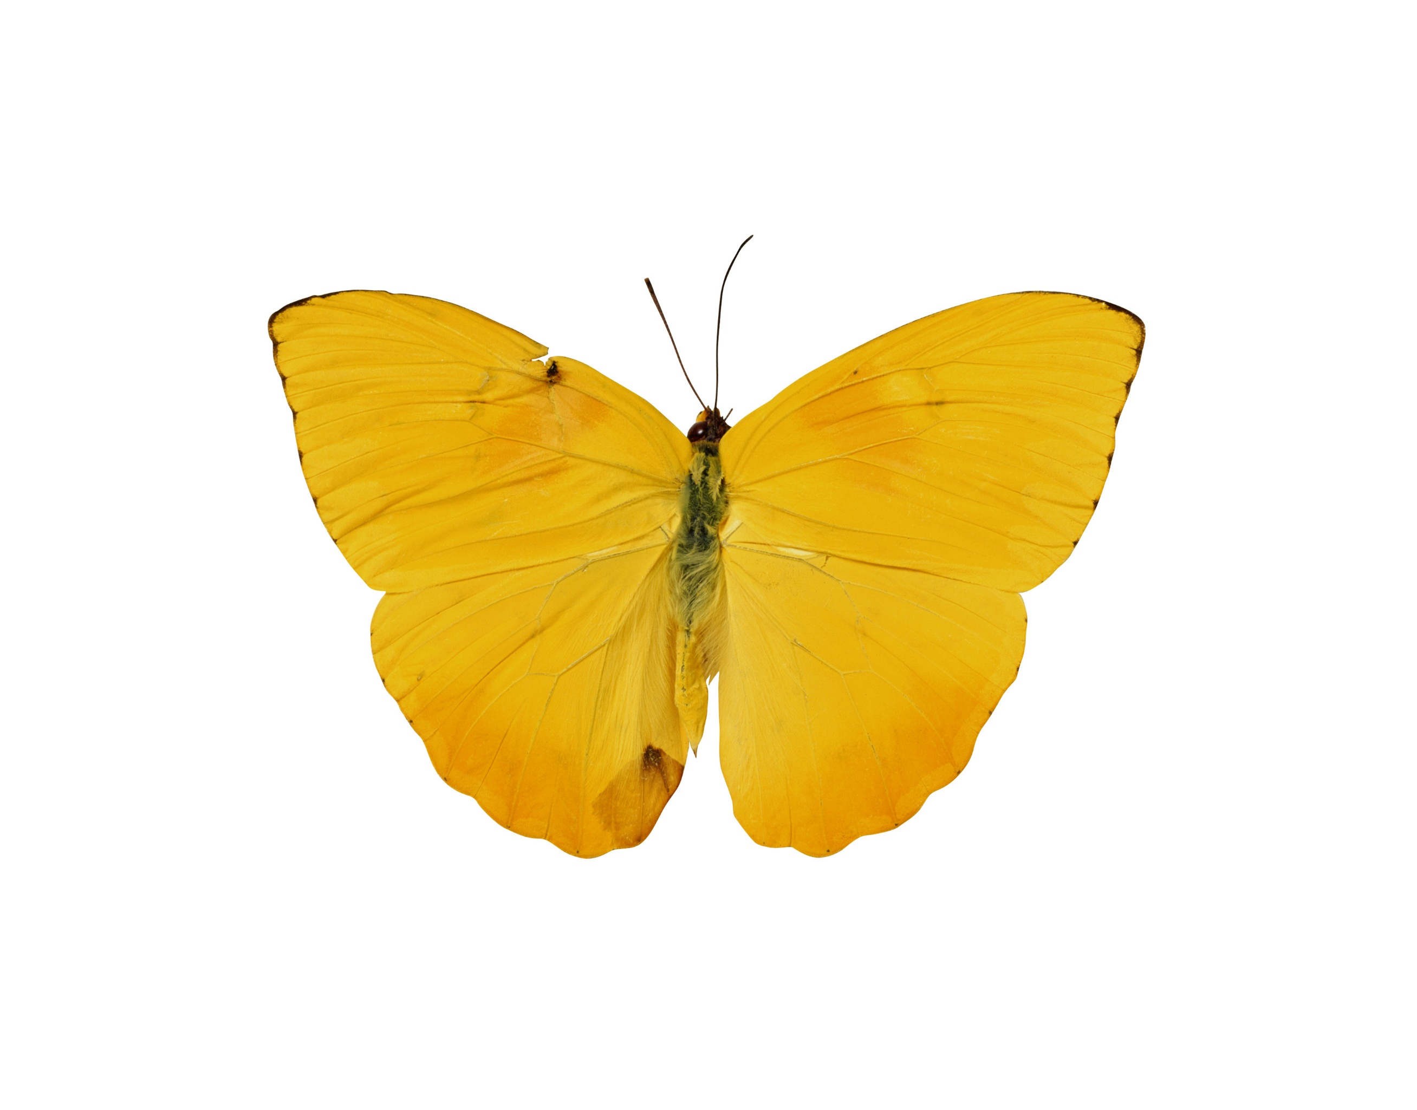

Vesa Juvonen  
[Course Title]  
[Teacher’s Name]

[Report Title]

# Get Started Right Away

This placeholder text includes tips to help you quickly format your report and add other elements, such as a chart, diagram, or table of contents. You might be amazed at how easy it is.

# Look Great Every Time

* Need a heading? On the Home tab, in the Styles gallery, just click the heading you want. Notice other styles in that gallery as well, such as for a quote or a numbered list.
* You might like the photo on the cover page as much as we do, but if it’s not ideal for your report, right-click it and then click Change Picture to add your own.
* Adding a professional-quality graphic is a snap. In fact, when you add a chart or a SmartArt diagram from the Insert tab, it automatically matches the look of your report.

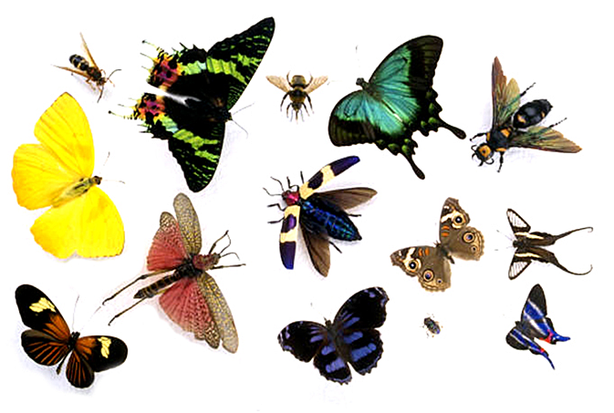

## Give It That Finishing Touch

Need to add a table of contents or a bibliography? No sweat.

### Add a Table of Contents

It couldn’t be easier to add a table of contents to your report. Just click in the document where you want the TOC to appear. Then, on the References tab, click Table of Contents and then click one of the Automatic options.

When you do, the TOC is inserted and text you formatted using Heading 1, Heading 2, and Heading 3 styles is automatically added to it.

### Add a Bibliography

On the References tab, in the Citations & Bibliography group, click Insert Citation for the option to add sources and then place citations in the document.

When you’ve added all the citations you need for your report, on the References tab, click Bibliography to insert a formatted bibliography in your choice of styles.

And you’re done. Nice work!